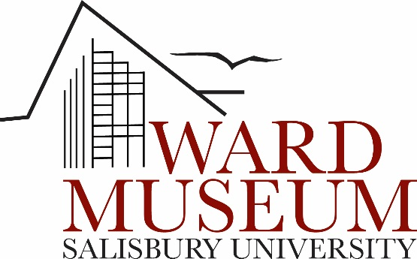

2017-18 Graduate Assistantship

Exhibits Department

Supervisor: Jackson Medel, Director of Exhibitions and Research, Ward Museum; jtmedel@salisbury.edu

Work Dates: 2017-18 school year, with the possibility of renewal

Hours/Week: 20

Location: Ward Museum of Wildfowl Art, 909 S. Schumaker Dr., Salisbury, MD 21804

Application Deadline: Open until filled- review of resumes will begin on June 20, 2017 for candidate selection by August 1, 2017.

How to apply: Send a cover letter and resume or CV to jtmedel@salisbury.edu

Overview:
What does a museum’s exhibits department do? How do collections management, exhibit preparation, and public programming work? This assistantship will draw on applied anthropological and public history approaches to museum studies, folklore, tourism, heritage conservation, art, and the environment as the Graduate Assistant immerses his- or herself in a museum setting, assisting in day-to-day activities of the Ward Museum of Wildfowl Art’s Exhibits Department, working directly with the Director of Exhibitions and Research. Hands-on experience may be provided in the areas of archival organization, material culture documentation, folklore research and organization, grant writing, non-profit management, and other areas as dictated by student interests and museum needs.

Compensation:
This is a paid assistantship ($4,000/semester) with tuition assistance. The appointment is contingent upon the student’s admission, enrollment, maintenance of minimum credit requirements, and good standing in a graduate degree program at Salisbury University Fulton School of Liberal Arts. The student must maintain a 3.0 cumulative GPA in order to retain her/his assistantship. To be eligible for the tuition waiver, the student must enroll for a minimum of six credits in the fall and spring semesters. Tuition is waived only for graduate courses applicable toward degree requirements.

About the Ward Museum:
The Ward Museum of Wildfowl Art, Salisbury University strives to lead the way for advancing the understanding of wildfowl art and the interrelationships of art, nature, and culture. Through educational programs, exhibits, and events the Ward Museum builds upon the legacy of wildfowl carvers Lem and Steve Ward in order to bring young and old to a greater understanding of the human relationship to the natural world.

The Ward Museum is a premier educational facility for the study of material culture, living traditions, and environmental concerns for the school children, scholars, and artists who are a part of the community the museum serves. It is accredited by the American Alliance of Museums.

