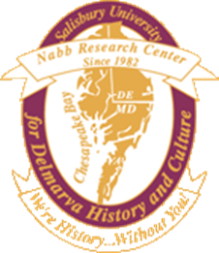
2017-18 Graduate Assistantship

Archival Management

Supervisor: Creston Long, Director, Edward H. Nabb Research Center for Delmarva History and Culture, cslong@salisbury.edu

Work Dates: 2017-18 school year, with the possibility of renewal

Hours/Week: 20

Location: Nabb Research Center, Guerrieri Academic Commons, Salisbury University campus

Application Deadline: Open until filled- review of resumes will begin on June 20, 2017 for candidate selection by August 1, 2017.

How to apply: Send your CV or resume and a short letter of intent (outlining the benefits of the assistantship for your graduate career and the qualities you would bring to it) to Professor Céline Carayon, Graduate Director, History Department

Overview:
History Department graduate assistants assigned to the Edward H. Nabb Research Center for Delmarva History and Culture work primarily with the local history and university archivists. They learn how to organize, process, and catalog manuscript collections. Work also includes digitizing sources, developing collections finding aids, and identifying items that may be featured in Nabb Center exhibits. This assistantship provides valuable work experience for any student interested in archival or museum work, and it greatly enhances the student’s historical research skills. Recent graduate assistants have gone on to work in museums and public parks.

Compensation:
This is a paid assistantship ($4,000/semester) with tuition assistance. The appointment is contingent upon the student’s admission, enrollment, maintenance of minimum credit requirements, and good standing in the History graduate degree program at Salisbury University. The student must maintain a 3.0 cumulative GPA in order to retain her/his assistantship. To be eligible for the tuition waiver (not including fees), the student must enroll for a minimum of six credits in the fall and spring semesters (students might be allowed to take a reduced credit load). Tuition is waived only for graduate courses applicable toward degree requirements.

About the Nabb Center: The mission of the Nabb Research Center is to cultivate and sustain the advancement of scholarly research through collecting, preserving, disseminating and providing access to records and artifacts which illustrate the rich historical and cultural heritage of the greater Chesapeake (Delmarva) region.

