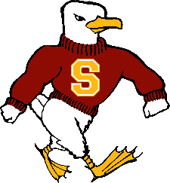

Salisbury University
Intramural Sports Supervisor Responsibilities and Duties
410-548-3266 (Office, Brandon Smithson)

The Intramural Sports Supervisor will assist the Director of Intramural Sports
(Brandon Smithson) in the operation of the Intramural Sports program at Salisbury University. The position involves working evenings and weekends.

Responsibilities include, but are not limited to, assisting in the following areas:

A. Intramural Sports
1. Review and apply rules for each intramural sport.
2. Use IMLeagues to monitor registrations, roster management, scheduling and maintain standings of all sports.
3. Communicate intramural sports policies and procedures.
4. Scheduling of indoor and outdoor facilities.
5. Maintain and organize all equipment and awards for distribution and use.
6. Monitor field conditions for risk management.
7. Report facility work order requests to the Director of Intramural Sports
8. Generate all intramural sports reports as established by Camus Recreation.
B. Student Employee Development and Supervision
1. Student staff and sports officials’ recruitment and hiring.
2. Student Staff and officials training and development.
3. Student staff and officials scheduling, supervision and evaluation.
C. General
1. Assist Campus Recreation Team in various functions and responsibilities as needed.
2. Expected to work between 10-18 hours a week
3. Other duties as assigned.

**PLEASE EMAIL RESUME & COVER LETTER TO
BPSMITHSON@SALISBURY.EDU **

Sincerely,

Brandon Smithson

Brandon Smithson, M.A.
Director of Intramural Sports
Asst. Mgr of Facilities
Salisbury University Campus Recreation
(410) 548-3266 l Maggs 146

