Trouble shooting problems.

Trouble opening attachments Pop-up Blocker should be turned off to look at the attachments.

↓
↓
←
↑
Click on tools I have highlighted two spots depending on where it is on your computer.
↓
↑

Explorer:
You may have to clear your cache.

Click on Internet Options
.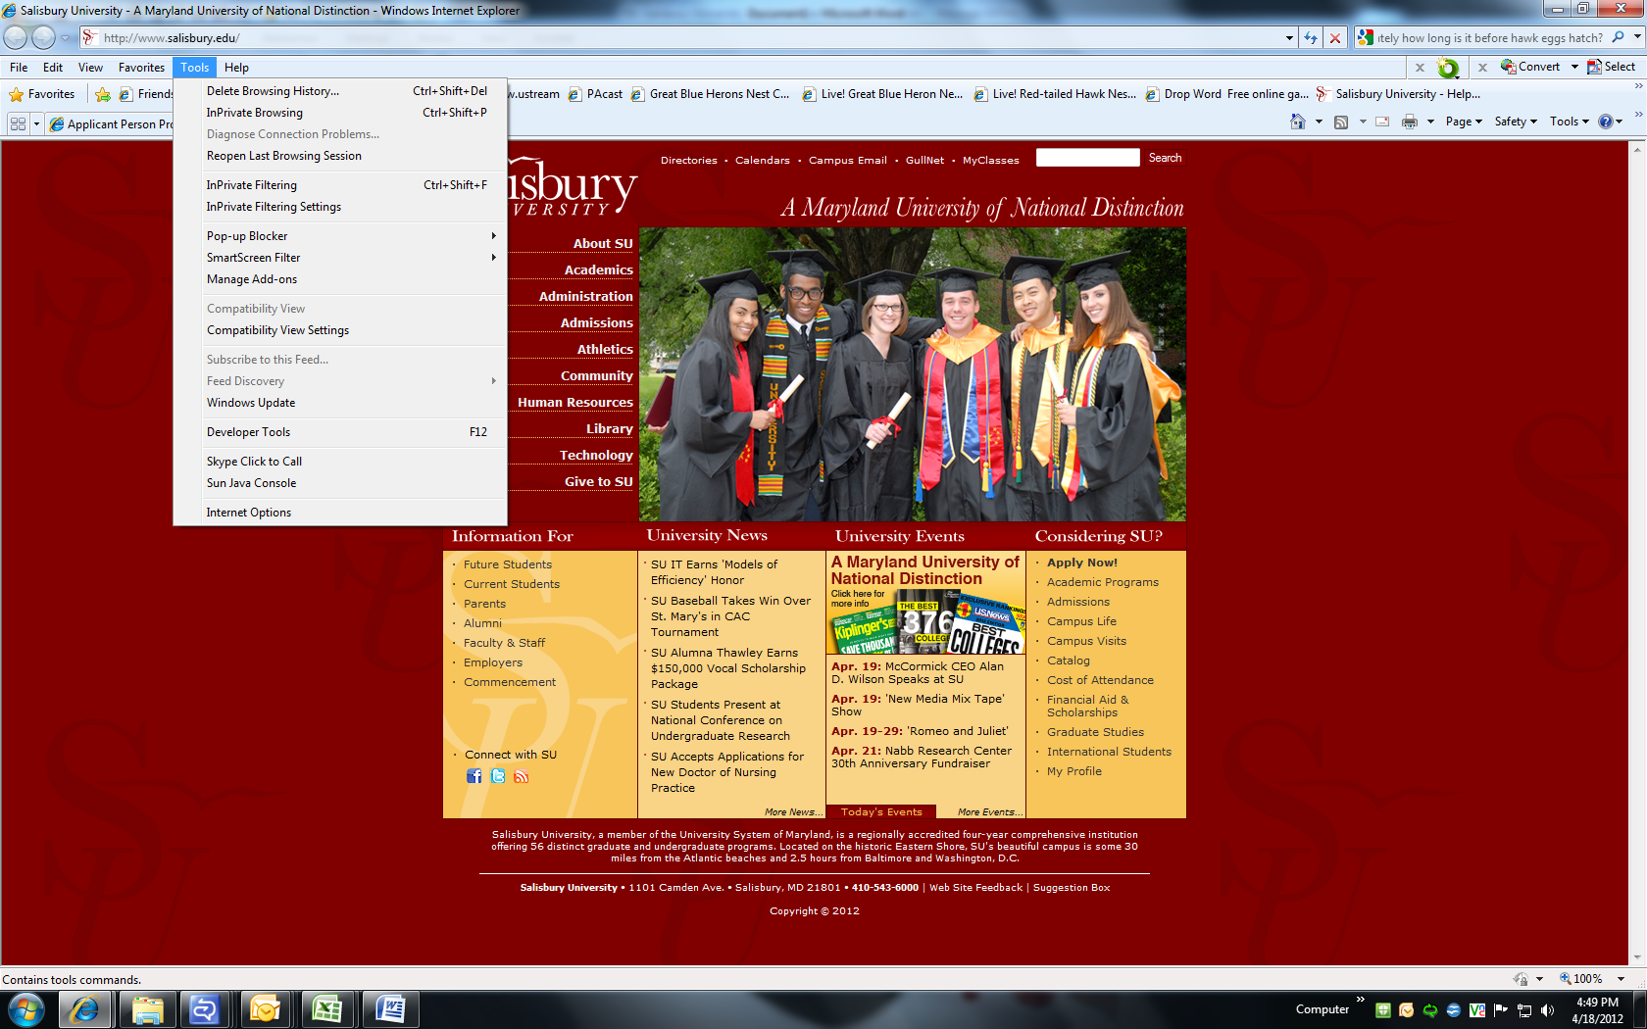
→

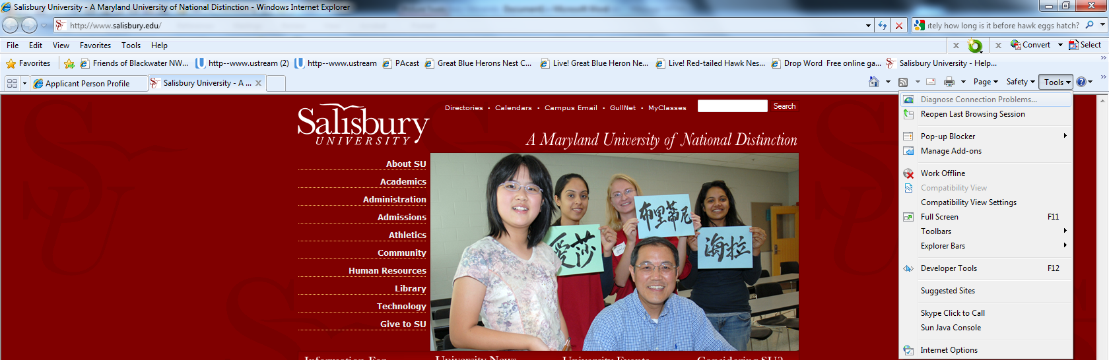
↖

↑
↙
→

See the checked boxes

↑

Mozilla Firefox

Log onto Mozilla Firefox

Click on Tools, then click on Options

Click on Privacy, then click on the Show Cookies button

Click on Remove All Cookies button (make sure pop-ups are not blocked)

