

**Table of Contents**

1. Introduction to Navigate pg. 1
2. Navigate Help Center pg. 1
3. Logging into Navigate pg. 1-3
4. Home Page pg. 3

* Upcoming Appointments
* Recent Appointments

1. Availability pg. 3-6

* Adding Program Planning Availability
* Adding Office Hours Availability
* Copying and Deleting Times

1. Running Targeted Campaigns pg. 6-13
2. Opening an Individual Student Record pg. 13-19

* Overview
* Ways to Record Interactions
* Message Student
* Add a Note
* Add a Reminder
* Report on Appointment
* Add to Watch List
* Links
* Success Progress
* History
* Class Info
* Major Explorer
* Path
* More

1. Reminders pg. 19
2. Advanced Search pg. 19-22

* Student Information
* Enrollment History
* Area of Study
* Performance Data
* Term Data
* Course Data
* Assigned To
* Goals & Interests
* Surveys
* Success Indicators

1. Taking Action on Multiple Students pg. 22-23
2. Watch Lists pg. 23-26

* Creating Watch Lists
* Create Watch List or add student through Advanced Search
* Upload Watch List from a list of Student IDs
* Add Students to Watch List form Student Profile

1. Navigate App pg. 26-31

* Instructions for Download
* Intake survey
* Screens shots: Landing Page, To-Dos, Study Buddies, Resources,

Active Holds, Courses-schedule View, List View, My Major

**Introduction to Navigate**

Navigate is both an advising and communication tool. To start, faculty and staff are able to access information about individual students as well as groups of students more easily. In addition, they can communicate with students directly through the platform, and each interaction is recorded for other faculty and staff to see. Tracking notes and interactions creates a more complete picture of where the student stands and who else on campus is working with him/her. The ultimate goal of Navigate is to support students on their path to timely degree completion.

Students do not have access to the information that is found/recorded in the Navigate platform. However, all information is part of a student’s record and will be shared if the student requests it or if we are served a subpoena. Note: Be thoughtful about what you include and the language that you use.

If you would like to show a student something in the Navigate platform, you should scroll to the bottom of their Overview page and click “Student View.” You will know that Student View is activated when you see the button turn green. The Student View strips away the Predicted Risk Level.

**Navigate Help Center**

This manual is meant to introduce you to Navigate basics. There is also a robust Help Center built right into the Navigate platform. Access it by clicking on the “?” in the upper right-hand corner.

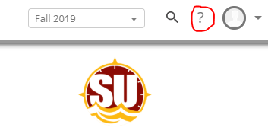

**Logging into Navigate**

* There are four ways to access the Navigate platform.
* In all cases, use Chrome.
* In all cases, use your GullNet Username and Password to log in.
* Address – <https://salisbury.navigate.eab.com/staff>
* From the SU Homepage, under the Faculty/Staff tab, click on Navigate

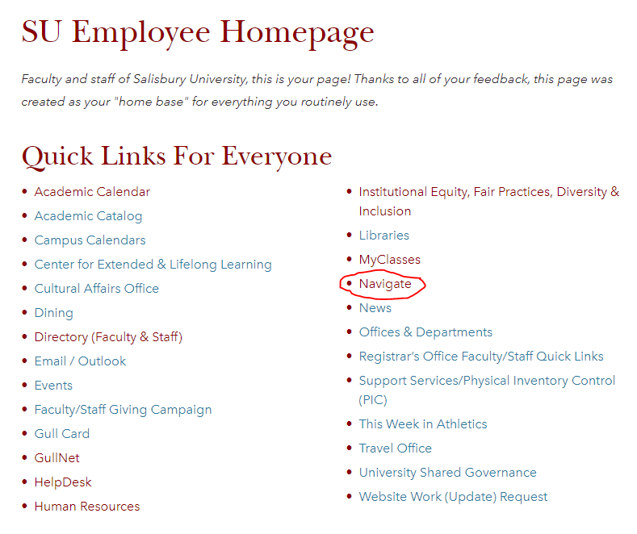

* On the GullNet Homepage, in the upper right hand corner, Navigate is one of the External Links

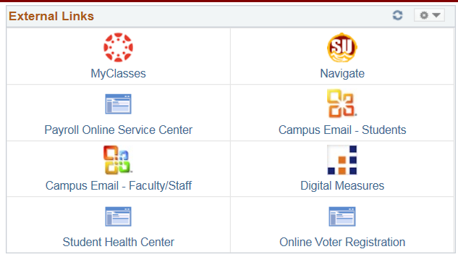

* In GullNet’s Student Services Center, there is a Navigate button on left side (see highlight below)

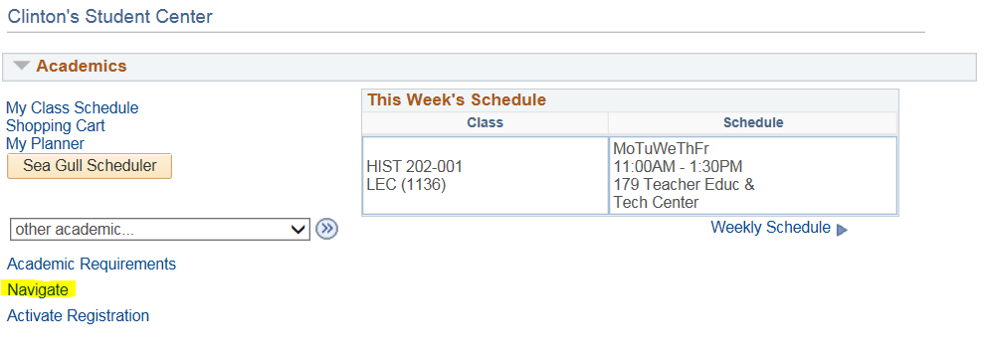

**Home Page**

After signing in to Navigate, you are brought to a Home Page.

* The Staff Home shows advisees who are assigned to you.
* The Professor Home shows classes you are teaching and the students in your classes (Graduate students are not showing currently)

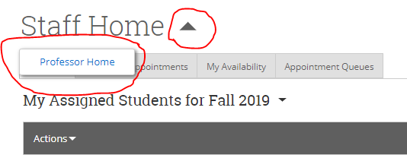

Upcoming Appointments

* Will list anyone who has set up an appointment through Navigate Student to meet with you

Recent Appointments

* Will track anyone who has an Appointment Report filled out from you – whether they originally set up an appointment with you or not

**Availability**

The “My Availability” tab is where you set up your available times to meet with students. You can set up different times for different types of meetings (i.e.: Advising/Program Planning, Office Hours, etc.) You can set the appointments for a range of dates (Program Planning), a specific term (Office Hours), or make it never-ending.

NOTE:

* Program Planning appointment availability will no longer be done in GullNet.
* You are able to set up availability for multiple types of appointments: Program Planning, office hours, research mentorship, etc.
* If your availability is set up in Navigate, students can sign up for an appointment through the Navigate student app.
* When students sign up for an appointment through Navigate, they are sent an email reminder the day before and a text message reminder 30 minutes before.

You set up availability in Navigate so that students can schedule appointments to see you – or know when you are available for walk-ins. Separate (but overlapping) times can be set up for Program Planning, office hours, research mentorship, etc. Note that locations and services can be updated upon request, so contact Melissa Boog, Heather Holmes, or Sarah Timko-Jodlbauer if you would like to see something added.

**Adding Program Planning Availability**

**Step 1:** Across the top navigation bar, make sure the term is set to the term you are working with.



**Step 2:** Click on the third tab (My Availability) and choose Add Time in the Actions dropdown.

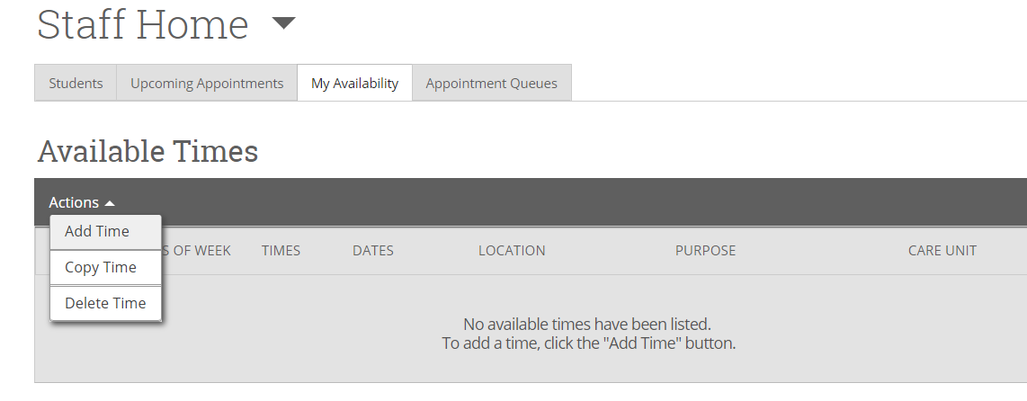

**Step 3:** Select the days and times when you are available to meet with students. (You don’t have to block off your teaching schedule; Navigate already knows that you aren’t available at those times.)

**Step 4:** Select A Range of Dates. Note: Fall 2019 Faculty Advising officially runs from October 7 – October 18. However, you may extend that timeframe if you wish. You may start as early as September 23.

**Step 5:** Click on “Appointments.”In addition, always click on “Campaigns” in case you decide to target students through a campaign (more information to follow). Note: For Program Planning, students must sign up for an appointment at least 24 hours in advance.

**Step 6:** Choose “Advising” under Care Unit.

**Step 7:** Choose “Faculty Advisor’s Office” under Location.

**Step 8:** Choose either 15-Minute Program Planning, 20-Minute Program Planning or 30-Minute Program Planning, depending on how long a typical appointment lasts for you. If you would like students to choose the amount of time they think they need, you can choose more than one option.

**Step 9:** Enter any special instructions you may want to share with your advisees (e.g. Office located in Henson Hall Room xxx; Please come prepared with a list of courses you plan to take in the spring; etc.)

**Step 10:** Leave Max Number of Students per Appointment set to 1.

**Step 11:** Click the Save button.

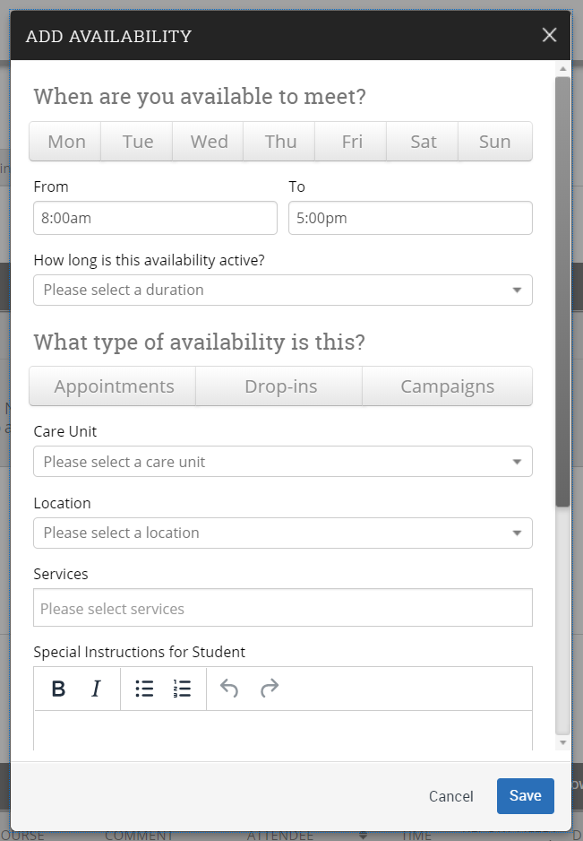

**Adding Office Hours Availability**

**Step 1:** Across the top navigation bar, make sure the term is set to Fall 2019.

**Step 2:** Click on the third tab (My Availability) and choose Add Time in the Actions dropdown.

**Step 3:** Select the days and times when you plan to hold office hours.

**Step 4:** Select Fall 2019 in the “How long is this availability active” dropdown.

**Step 5:** Click on “Appointments” if you are willing to have students make appointments during your office hours. Click “Drop-ins” if you prefer for students to drop in instead of signing up in advance. You may click both if you are ok with either. In addition, always click on “Campaigns” in case you decide to target students through a campaign (more information to follow).

**Step 6:** Choose “Faculty Office Hours” under Care Unit.

**Step 7:** Choose “Faculty/Professor’s Office” under Location.

**Step 8:** Choose the appropriate service you plan to provide to students during your office hours. You can list a specific timeframe or leave it open by simply choosing “Office Hours.”

**Step 9:** Enter any special instructions you may want to share with your students (e.g. Office located in Perdue Hall Room xxx; If you are bringing snacks, I prefer dark chocolate; etc.)

**Step 10:** Change the Max Number of Students per Appointment if you are willing to meet with more than one student at a time.

**Step 11:** Click the Save button.

Other Available Times Options…

**Copy Time** - To copy a time, select the time you would like to copy and then click the Copy Time button. The availabilities will be copied and a dialog will open allowing you to make edits or to save your newly created availability. (If your original time had a range of dates, you will have to update them in the new version.)

**Delete Time-** To delete your time, simply select the time and click the Delete Time button.

**Note:** Inactive availabilities are highlighted in red in the Times Available grid. That simply means that we are outside of that time period. However, students can see the times you have set for the future and are able to set appointments for those times before they are active.

**Other Reasons to Set Availability?**

If you would like to set availability for reasons other than Program Planning and Office Hours, we may be able to add that functionality. Please contact Melissa Boog, Heather Holmes, or Sarah Timko-Jodlbauer with your request.

**Running Targeted Campaigns**

An Appointment Campaign allows faculty and staff to reach out to specific populations of students to encourage them to schedule appointments. This functionality is commonly used when you have identified a population of students in need of additional support and you are sending them a request to schedule an appointment with you. Program Planning is a perfect time to run a campaign.

**Launching an Appointment Campaign**

To begin, click Appointment Campaigns in the Actions or Quick Links menu.

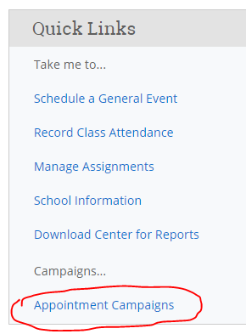

In the Actions menu, choose the type of Campaign you would like to run. In this case, choose Appointment Campaign.

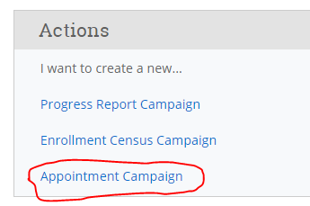

**Define the Campaign**

In this step, you will set the criteria for your Appointment Campaign. The fields that must be filled out are listed and defined below. Note that if other staff are going to be included on this campaign, the reason/location/date range must align with Campaign Availability for the advisor(s) that are going to be included in the campaign.

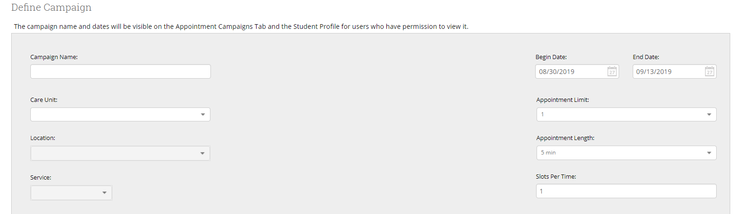

* **Campaign Name:**Campaign Name is visible to the person creating the campaign and any other users who have access to view campaigns; it is not visible to the student. Make sure to adhere to SU’s naming convention. It will make it easier to track the impact of your campaigns.

Include the following in your name: Term, College, Purpose, Last name of user who created the campaign (Example: Fall 2019 Program Planning Boog)

* **Care Unit:**Select the Care Unit the Appointment Campaign will be associated with
* **Location:**Select the location of where the appointment(s) will be held.
* **Service:**Select the Service that will be associated with the campaign
* **Course or Reason:**Add the reason or associated course for the campaign here. This will only appear if the Service is tied to a course
* **Begin and End Date:** These are the dates that you want students to start and stop making appointments for the campaign.
* **Appointment Limit:**This will determine how many appointments you wish for the student to schedule during the campaign.
* **Appointment Length:** This is where you define exactly how long the appointment will be.  Durations begin at a 5 minute length and will be determined by your configuration.
* **Slots per Time:**Appointments can be individual or group. By adding more than one "slot per time", you can have a group appointment.

**Add Students to Campaign**

After entering the details on the Define Campaign page, click Continue.

Your next step is adding students. If you created this campaign directly from a Watch List or Saved Search, you will be asked to review your students. If not, you can invite all of your assigned students or use the Advanced Search to pull a population.

If you choose the Advanced Search option,you will be presented with a list of students and must select the students you wish to add. Then choose **Add Selected Users and Search for More** from the actions menu.

You can remove students from the campaign if needed. For example, if you met with one of the students already and don't need them to come in during the campaign period, they can be removed.

Once finished, click **Continue** to move to the next page.  You will be asked to review the students in the campaign. If these are correct, click **Continue**.

**Add Staff to Campaign**

You will need to select yourself as staff for the campaign. You may also have the option to select additional staff to make them available for appointments based on the campaign.

NOTE: Staff will need to have availability defined before they can be added to an appointment campaign. If you do not see staff you expected to have availability, make sure their calendars and availability are up-to-date.

**Compose Your Message**

Your next step is to compose the message that you will send to students. DO NOT REMOVE THE SCHEDULE LINK FROM THE EMAIL BODY.

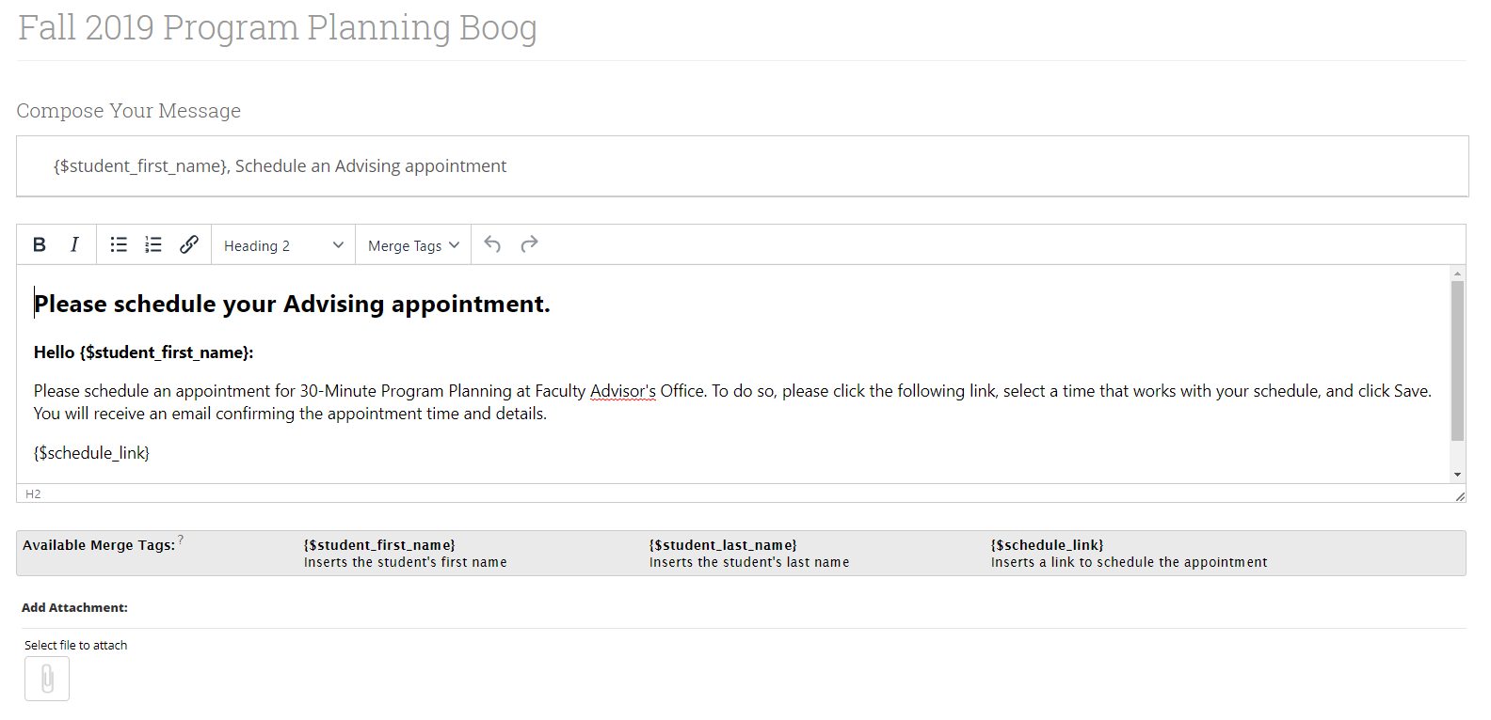

Fields used in the message composition are:

**Email Subject:**  The topic will be the subject of the email going to the student.

**Instructions or Notes:** This will be specific to the landing page students will be taken to when they click on the link in their email to choose the date and time of their appointment.

Note that you can include attachments.

You can preview how the email will look at the bottom of the page. 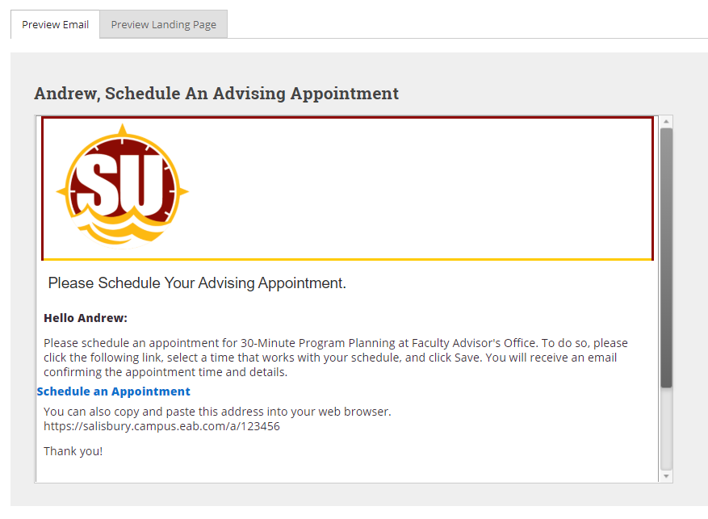

After you have finished composing and previewing your message, it's time to send out your campaign!

Review your campaign details, invitees, and advisors on this page.

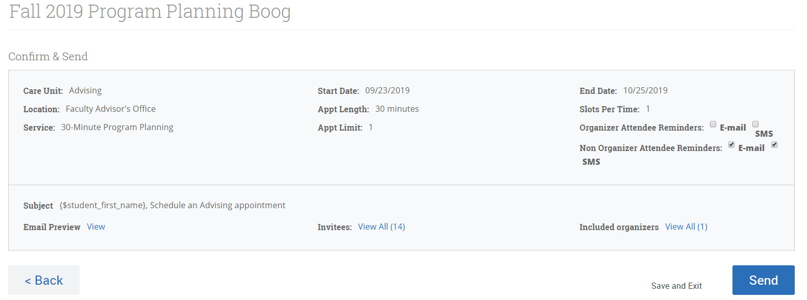

Click **Send** when you are ready to email the invites to the selected students.

**Managing Your Campaign**

The platform gives you tools to manage your appointment campaign once it has been created and sent.

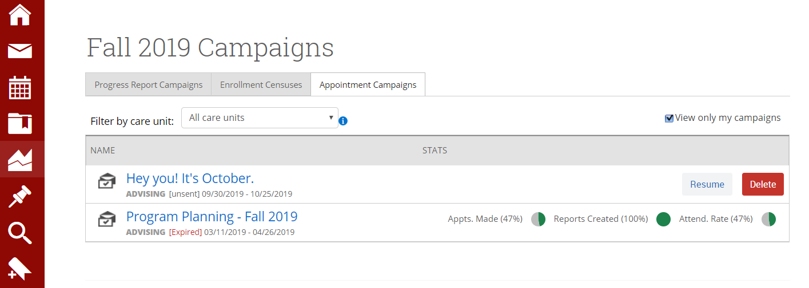

On the Appointment Campaigns tab, you will see three at-a-glance statistics if the campaign is active: Appts. Made, Reports Created, and Attend. Rate.

Here are the definitions for these metrics:

* **Appts. Made:** the % of appointments scheduled by students on the outreach list
* **Reports Created:** of the appointments scheduled, % of summary reports filed for those appointments
* **Attend. Rate:** of the appointments scheduled and summary reports filed, % of students were marked as having attended the appointment

To see more details, select an Appointment Campaign name to drill into.

This page allows you to edit or delete the campaign. It also gives you crucial information about the campaign, broken down into four tabs of information, described below.

**Appointments Made:** This tab lets you see which students have made appointments. Not only can you view those students individually by selecting their name, but you can also Send a Message and/or Add Note for an individual student or for the group as a whole.

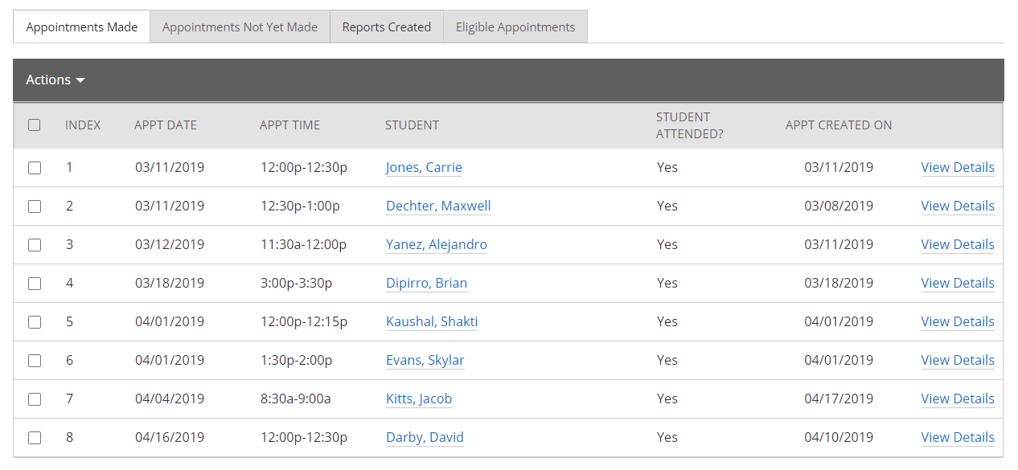

**Appointments Not Yet Made:** This tab will display those students who have not yet made their appointment(s). The Actions menu allows you to Send a Message, Add Notes, Resend the Campaign Email, or Add Tags for the students individually or as a whole.

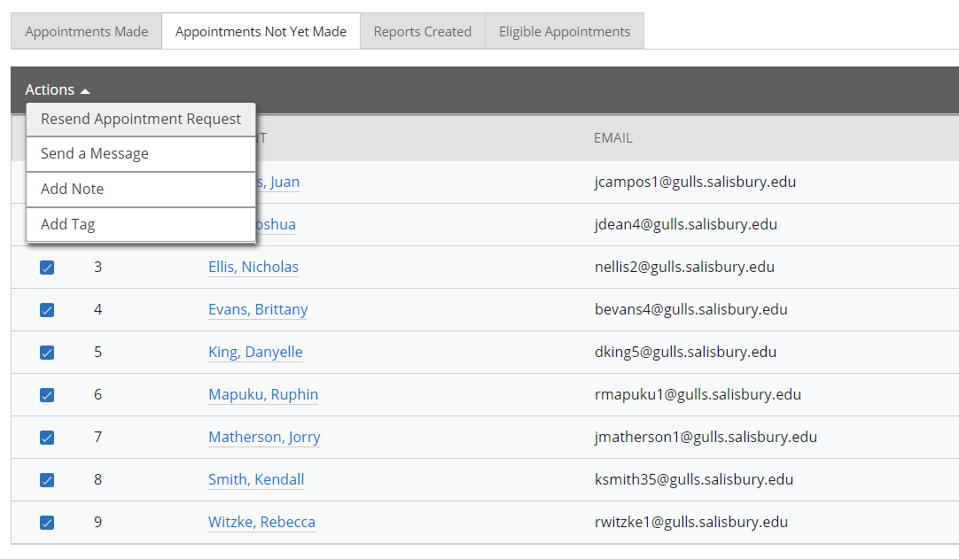

**Reports Created:** This tab will list any summary reports made from the campaign. From this tab you can view the detailed report or delete the report.

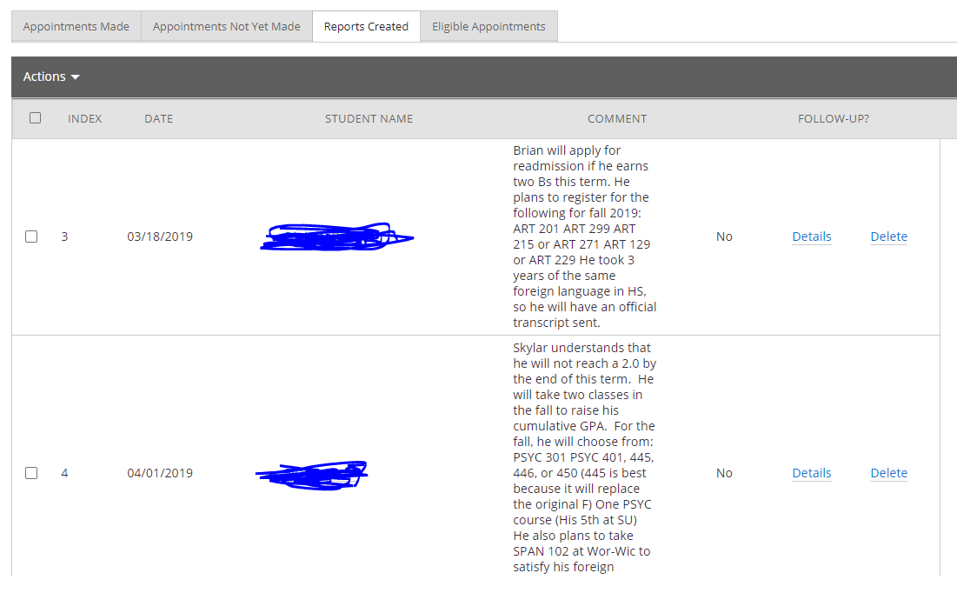

**Opening an Individual Student Record**

You can click on a student in your Home Page list or Search for a student in the upper right-hand corner.

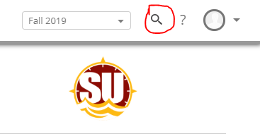

Overview

Dashboard Features Include:

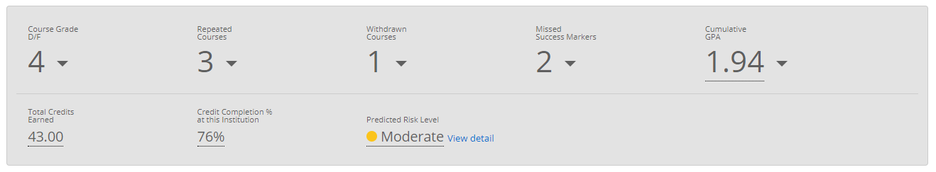

**Repeated Courses** include Special Topics courses, so it’s not always a negative indicator when students repeat. Open the dropdown to see the detailed list of courses.

**Cumulative GPA** is based on the courses the student has taken at SU. Transfer grades are not included.

**Credit Completion** % is only based on the courses the student has taken at SU. Transfer credit is not included.

**Predictive Risk Level**

* Red = High Risk, Yellow = Moderate Risk, Green = Low Risk
* The Risk Level is the estimated likelihood of this student persisting and graduating with this particular major. It is based on the outcomes of similar students who attended SU over the last ten years.
* The Risk Level is not a crystal ball! It is a starting point for conversation.
* The Student View removes the Risk Level (as well as other things) from the display.

**Goals and Interests** are pulled from information students provided through the Navigate Student app.

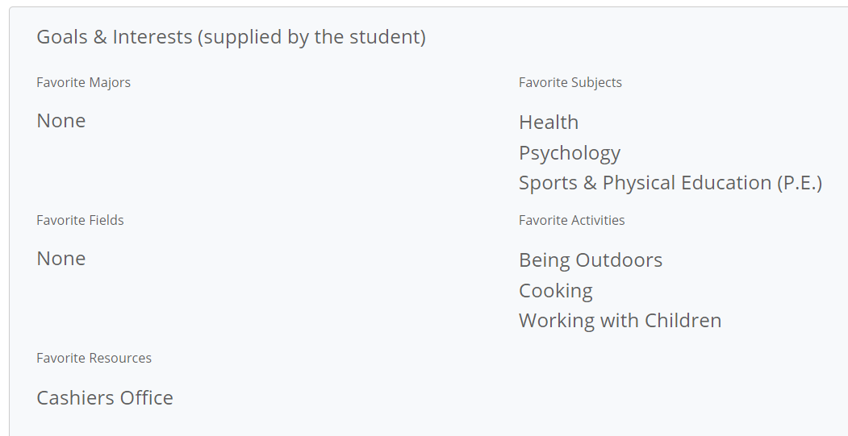

**Categories** shows a snapshot of special features of a student’s profile (i.e. – Academic Standing, Admit Type, their Cohort/term they matriculated, declared minor, whether they are involved with an LLC, TRiO, Powerful Connections, etc.)

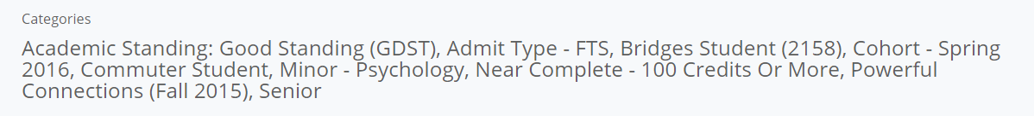

**Ways to Record Interactions**

There are many ways to take action on an individual student. They are listed on the right-hand side of the student page.

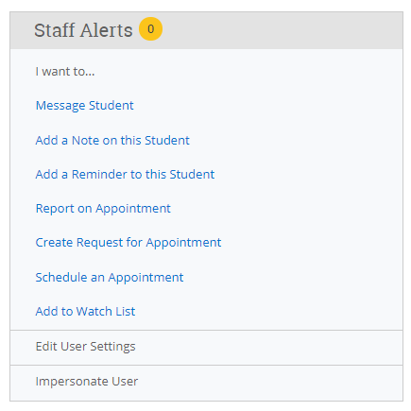

Message Student

* You can send an email to a student (including attachments)
* You can CC others
* Messages you send are recorded under the “More” tab under “Conversations”
* If a student responds, his/her response is also recorded there
* Your messages will also appear in your Outlook inbox and outbox. Note: They only appear in both places if the initial email was sent through Navigate.

Add a Note

* You can add notes to a student’s record (including attachments)
* It defaults to everyone (other than the student) being able to see the note; this is often a best practice
* These notes will be saved in the student’s History
* You can select your name only under “Visibility” if you want the note to only be visible to you. You should choose this option when your note references the Counseling Center or Disability Resource Center.
* You can choose the student’s name under “Visibility” if you want the note to appear in the Student View.

Add a Reminder

* You can add a reminder to yourself regarding a specific student. For example, you can remind yourself to check on their mid-term grade in a specific class. Or you can remind yourself to wish them luck on an upcoming test.
* Reminders are listed on the Reminder page and on the right-hand side of the Home page

Report on Appointment

* If a student stops in for an appointment (without scheduling one through Navigate in advance) you can record your interaction through the official report form.
* Once you choose a Care Unite (i.e.: Advising, Office Hours), some of the report will populate for you and you will be prompted to answer a few questions.
* If you choose to fill out the report after the appointment is over, remember to change the meeting start and end time.
* This report will be saved in the student’s History and can be viewed by anyone who has access to the platform.

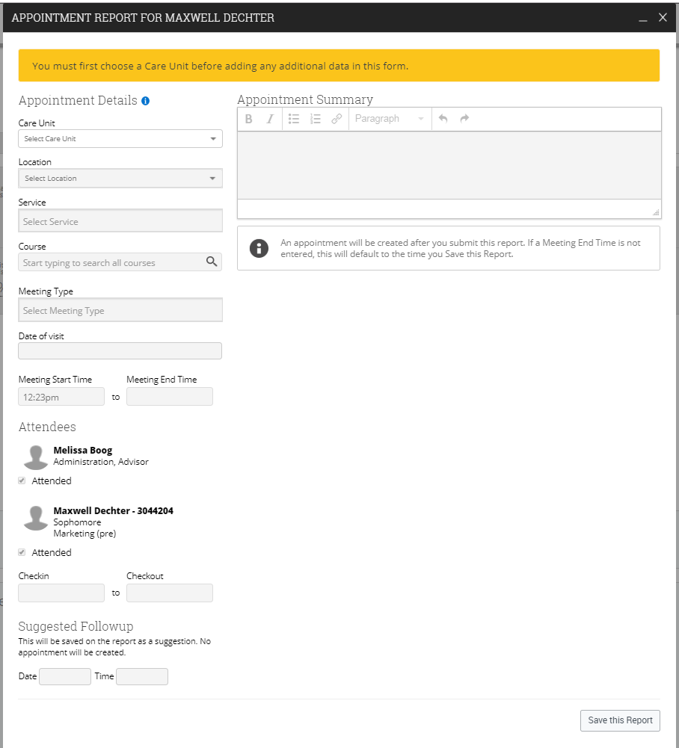

Create Request for Appointment

More information to come.

Schedule an Appointment

You can manually schedule an appointment for an individual student.

When in an individual student’s record, click on “Schedule an Appointment” from the right-hand menu.

Add to Watch List

From the individual student page, you can manually add a student to a Watch List. A Watch List is a static list of students. You can create multiple Watch Lists. This feature is best when you would like to track students over time. See page ___ for instructions on how to create and maintain Watch Lists.

Links

The Links area contains links to outside sources. Currently you can move directly to GullNet and the Curriculum Guides. Links are listed in the gray block on the right side of the student page. If you have a suggestion for another helpful link, please contact Melissa Boog.

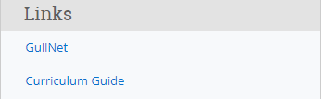

The tabs across the top of the screen provide more information about the individual student.



Success Progress

Under Success Progress you can view completed, missing, or upcoming Success Markers. You can also view a graph of GPA Trends by term and Credit Trends by term.

Success Markers are courses critical to progress in the student’s major. It may be the course itself, the grade, or the timing that is especially important.

History

History will show any notes or reports added by faculty and staff.

Class Info

Class Info includes classes this term as well as a full transcript, including courses, grades, term and cumulative GPAs, academic standing **and** transfer courses/grades, high school name, and standardized test scores.

More

Under “More” you will find Calendar, Study Hall, Appointments, and Conversations.

* Calendar

The calendar shows the student’s class schedule in a monthly calendar format including the class location.

* Study Hall

The Study Hall feature is not currently active.

* Appointments

Shows any recent or upcoming appointments that the student has scheduled.

* Conversations

The Conversations tab tracks emails sent out through the Navigate platform as well as the student’s response(s).

**Reminders**



You will find Reminders under the thumbtack icon on the left menu. These are reminders you set for yourself. When on an individual student’s page, you can add a reminder about this student and assign a due date. When you click on the reminder icon, any reminders that you set for yourself will be listed there. They will also be listed on the right-hand side of your Home page.

**Advanced Search**



You will find Advanced Search under the magnifier icon on the left menu. By choosing criteria, you are essentially creating a query.

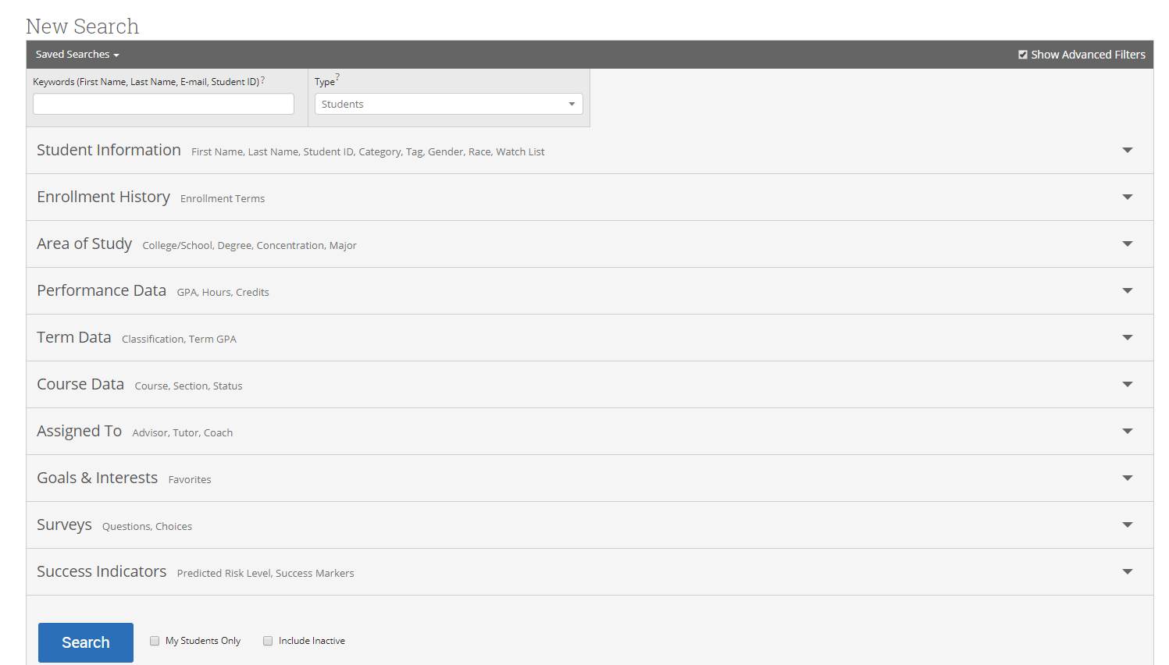

New Search

You will find the breadth and depth of the advanced search features listed under this heading.

My Students Only

Click “My Students Only” if you only want your criteria to pull from the list of students assigned to you.

Include Inactive

Click on “Include Inactive” if you want to pull inactive students as well as those currently active in the system.

Student Information

Click on student information to search by First Name, Last, Name, Student ID, Category, Tag, Gender, Race, Watch List.

Tag- Study Abroad is the only tag available currently.

Categories: For search options that weren’t delivered in the platform, Categories were created. If you know what you are looking for, you can start typing in the category – rather than scrolling through the list. Categories that are currently available:

* Academic Standing (Good Standing, Probation, Restricted, Dismissal)
* Admit Type (FTS, GSD, IFT, ITR, TRN, USB)
* Bridges Student (By Cohort)
* Cohorts (aka - Matriculation Term)
* Commuter Student
* Discontinued
* Expected Graduation (Term students applied to graduate)
* Honors College (Honors College and School-Specific Honors Programs)
* International Student
* LLC (Students currently enrolled in a Living Learning Community)
* Minor (Since we can only search by major in Area of Study section)
* Near Complete (Has 100 credits or more)
* On Campus
* Part-Time (Between 1 – 11 credits)
* Powerful Connections (By Cohort)
* Pre-Professional (Each of the Pre-Health and Pre-Law tracks are designated)
* Suspended
* Transfer GPA less than 2.5 (Students who transferred in with less than a 2.5 overall)
* TRiO (All students currently enrolled in TRiO)
* Undecided Majors
* Veteran and Military Connected

Note: If there are Categories you would like as options that aren’t available, contact Melissa Boog with suggestions.

If you hit the “+” button beside Category, you have the following options: “In All of These” and “In None of These”

Enrollment History – If you only want students enrolled in a specific term; terms go back to 2013.

Area of Study – Options within the area of study search include College/School, Major, Concentration, and Degree. Note: “In Any” means “or”, “In All” means “and”, and “In None” means that aren’t in any of these.

Performance Data

Search under this criteria by minimum cumulative GPA, maximum cumulative GPA, minimum credits earned, maximum credits earned, minimum hours attempted, maximum hours attempted, minimum credit completed and maximum credit completed (%). Minimum HS GPA and Maximum HS GPA are included, but we don’t have that info for transfer students.

Term Data

Within a specific term, search for minimum credit hours, maximum credit hours, enrolled with professor (lists each professor’s name), classification (Freshman, Sophomore, Junior, Senior, Adult Education, Continuing Education, Skills, Credits, and Other).

Course Data

Find info on courses within a term or over multiple terms. You can find students who are registered, have withdrawn, or have earned specific grades in specific courses. Search course data by each course (i.e. BIOL 310 Ecology, ENGL 221 Literature & Film, etc.) within a term or within a range of terms.

Assigned To

Search for students Assigned to a specific Advisor (populated with all academic advisors and faculty mentors). Aassigned to Tutor and Assigned to Coach will be available in a future phase of the roll-out.

Goals and Interests

This search field is currently under construction.

Surveys

This search field is currently under construction.

Success Indicators

Search under Success Indicators to sort by Predicted Risk level (low, moderate, high and unknown).

**Taking Action on Multiple Students**

At any point, if you have a list of students, you can take action on all of them. Click on All to choose the entire list. If your list contains more than 100 individuals, you must indicate that you want the full list included.

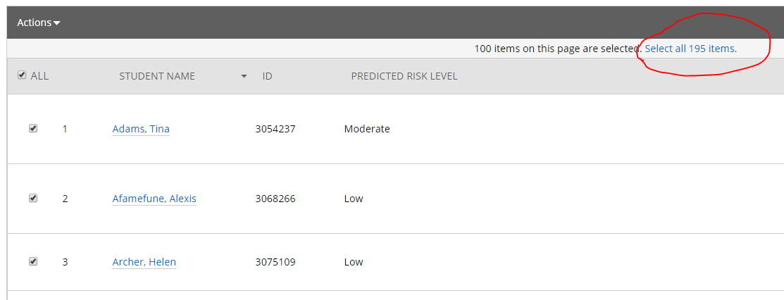

Once your students are selected, choose the action you want to take from the dropdown menu.

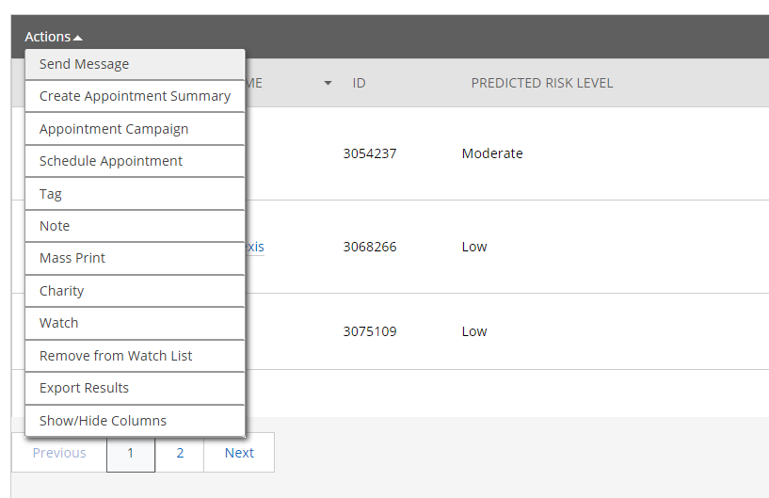

**Watch Lists**



A Watch List is a static list of students you would like to track over time. You will find Watch Lists and Saved Searches under this icon in the left menu. Click on New Watch List to create a list. Name the Watch List. When naming Watch Lists, include anything to help identify the qualities of the list. For example: USAL Fall 2019 for “All Undecided students enrolled for Fall 2019”

There are three ways to create a Watch List:

**Option 1 - Create Watch List or add student through Advanced Search**

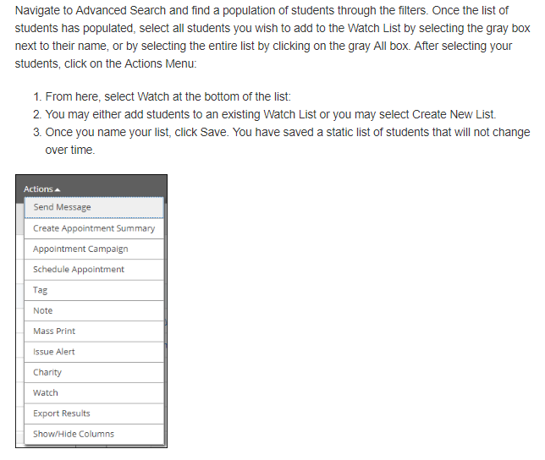

**Option 2 -Upload Watch List from a list of Student ID’s**

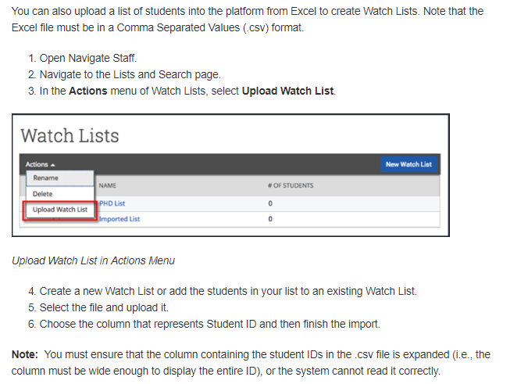

**Option 3- Add Students To Watch List from Student Profile**

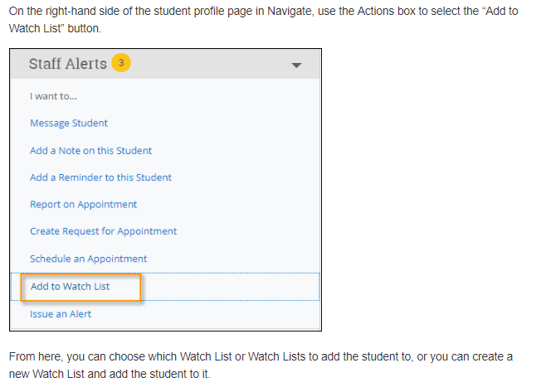

**Navigate Student App (for students only)**

Although students don’t have access to the Navigate platform, they do have access to a mobile app.

**Instructions to download the app (students only)**

* Open App Store or Google Play on your phone
* Search for “Navigate Student”
* Download (App takes the space of one selfie)
* Open App
* Search for Salisbury University
* Log in (using your Gullnet username and password)

**Then…**

* Go to settings
* Under My Stuff, click on Notification Settings
* Choose your preferences
* Recommended-Under Personal Reminders and Must Do Steps, opt in for Push Notifications and Text Messages

There is also a desktop version of the app. The link can be found on SU’s Homepage, under the Current Students tab. It is called Navigate Student.

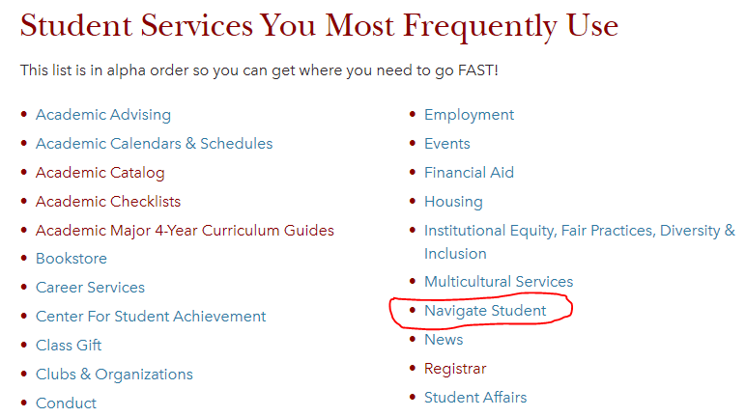

The first time students download the mobile app or open the desktop version, they are prompted to take a quick **Intake Survey**. Survey questions currently include:

This is my first semester at Salisbury University. Choose Yes or No.

I am (select all that apply)

* Planning to live off-campus
* The first in my immediate family to attend college
* Concerned about being able to finance my Salisbury education
* Concerned about balancing academic and social life
* A veteran or military connected student
* None of the above

I would like to receive more information about (select all that apply)

* Academic success services
* Accessibility/disability resources
* Counseling and mental health services
* None of the above

