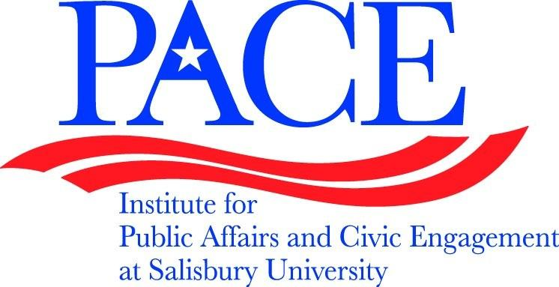 | PACE at Salisbury University  Fulton Hall, Room 258  (410) 677-5445  FAX (410) 677-5012  www.salisbury.edu/pace

Civic Engagement Across the Curriculum

What: Opportunity to build civic engagement components into existing courses
When: Thursdays, Septmeber 14th – November 16th, 3:30 – 4:45pm
Who: All SU faculty

The Institute for Public Affairs and Civic Engagement (PACE) at Salisbury University is accepting applications for the fall 2017 faculty professional development seminar, Civic Engagement Across the Curriculum (CEAC). The 10-week seminar assists faculty members of any discipline in integrating a civic engagement experience into an existing or planned course. The seminar will meet each Thursday from 3:30-4:45 beginning with a wine and chesse social September 14th. Faculty who successfully complete the program will receive a professional development allowance from the dean of their home academic school.

To apply for participation, please submit the following information to Dr. Sarah Surak by September 5th at smsurak@salisbury.edu:
- Name:
- School:
- Department:
- Proposed course for revision or development (Prefix, number, description):
Description:

  - Is this a new course? Y/N:
  - Semester/year the course will be taught:

For more information visit www.salisbury.edu/PACE

