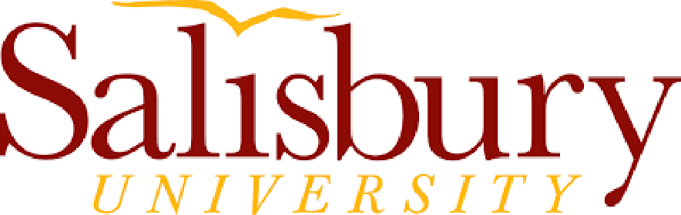

Employment Outcomes for Completers (2016-2017 and 2017-2018)
I. Percentage of graduates (based on responses to the alumni/completer survey) who indicated being employed in education
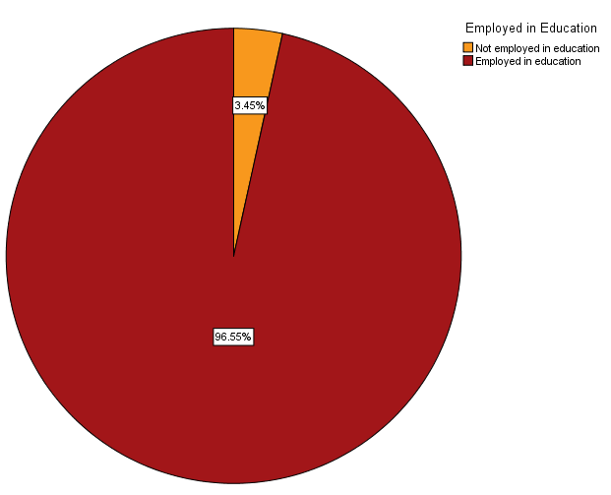

Note. Respondents who indicated enrollment in a graduate program were classified as being ‘unemployed’.

II. Common positions our graduates obtain (based on responses to the alumni/completer survey)
Educational position | Percentage Based on  2016-2017 Sample | Percentage Based on  2017-2018 (CDCP)
Full-time teacher | 75.6 | 55.2
Part-time teacher | Not reported | 3.4
Substitute teacher | 7.3 | 3.4
Paraprofessional/Paraeducator | 2.4 | Not reported
Reading specialist/interventionist/coach | Not reported | 31.0
Educational administrator | 2.4 | Not reported
Other educational employee | 7.3 | 3.4
Graduate student in education field | 4.9 | Not reported
Note. CDCP=current data collection period (September 1, 2017 – August 31, 2018). Not reported means that none of the graduates/alumni who completed the alumni survey indicated employment in the position. These findings depend on the representativeness of the sample obtained for the alumni/ completer survey (2017-2018), and should be viewed as approximate estimates.
III. Time-to-employment information for our graduates (in months, based on responses to the alumni/ completer survey)
Evaluation Items – Composite Score | Mean | Median | SD
2016 – 2017 | 2.78 | 2.00 | 4.28
2017 – 2018 (CDCP) | 1.61 | 1.00 | 2.25
Note. CDCP=current data collection period (September 1, 2017 – August 31, 2018). SD=standard deviation. These data are based on the following item from the alumni/completer survey: “Approximately how many months after graduation did it take you to obtain your job? (Note. If you obtained a position prior to graduating, please write zero (0) in the space below.)”

IV. Setting and location information for our graduates (based on responses to the alumni/completer survey)
School settings in which our graduates work | Percentage Based on  2016-2017 Sample | Percentage Based on  2017-2018 (CDCP)
Public school in Maryland | 65.9 | 90.0
Private school in Maryland | 7.3 | Not reported
Public school outside Maryland | 14.6 | Not reported
Private school outside Maryland | Not reported | 10.0
Areas (outside of MD) in which our graduates work
Virginia | 9.8 | Not reported
New Jersey | 2.4 | Not reported
New York | Not reported | Not reported
Delaware | Not reported | 5.0
Pennsylvania | 2.4 | Not reported
Florida | Not reported | Not reported
Other areas (e.g., California, Connecticut, etc.) | Not reported | 5.0
Note. CDCP=current data collection period (September 1, 2017 – August 31, 2018). Not reported means that none of the graduates/alumni who completed the alumni survey indicated employment in the setting or area. These findings depend on the representativeness of the sample obtained for the alumni/ completer survey (2017-2018), and should be viewed as approximate estimates.

