Salisbury University Web Development Office

Using the SiteImprove Plugin in the CMS

What is SiteImprove?
  - SiteImprove is a company who specializes in website governance. Salisbury University has partnered with SiteImprove as a way to govern content added to the University’s website to ensure it complies with 508 requirements and responsibilities.
- What is the SiteImprove Plugin for CMS?
  - Content added to our site is done through our CMS (Content Management System) accessed through cms.salisbury.edu. Content is added by content contributors who are made up of a diverse group of staff/faculty members.
  - The SiteImprove plugin provides a tool inside of the CMS that allows content contributors to check the accessibility of content on their pages.
- What is Accessible content
  - Accessible content is content that can be accessed by any user even users who use assistive technology such as screen readers, special input devices and even brail readers.
  - Not only does Accessible content help users who use assistive technology but studies have proven that Accessible content helps everyone understand and gather information from a site easily and more efficiently.

The following instructions explain how use of the new SiteImprove Plugin in the CMS

- Accessing the SiteImprove Plugin
  - You first need a SiteImprove account. If you did not receive and email asking to set a password for your SiteImprove account please contact the Web Office so we can set you up with an account. You can request access through our ticketing system located here Web Request System.
  - The next two steps depend on how you access the CMS.
    - If you log into the CMS by using the copyright symbol located at the bottom of a webpage. Upon loading into the CMS you should immediately see an icon (highlighted in the image below) about halfway down your screen all the way on the right hand side. This is the SiteImprove icon.
    - If you log into the CMS by going to cms.salisbury.edu you will first need to choose “SBYEDU” in the “site:” dropdown in the top left corner. Upon selecting “SBYEDU” you should see the SiteImprove icon located half way down on the right hand side (highlighted in the image below).
    - If you are viewing an individual page in the CMS you may notice the icon has a red number attached. That is the number of accessibility errors on a page and we will talk about this a little later in the document.
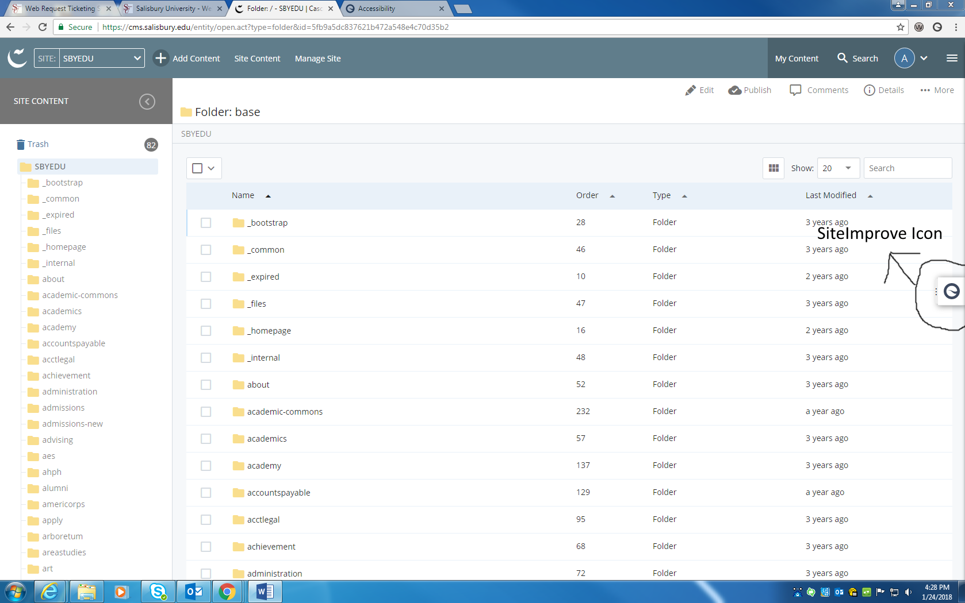
- Using the SiteImprove Plugin
  - The SiteImprove icon can be clicked to expand/hide the SiteImprove plugin (expanded view shown in image below).
  - When expanded the SiteImprove plugin provides three tabs each with unique data that can be leveraged to improve the accessibility of you site.
  - The tabs are “My history”, “Site overview”, and “This page”. These tabs are located at the top of the expanded SiteImprove plugin (highlighted in image below). If you are not viewing an individual page in the CMS you will NOT see the “This page” tab.
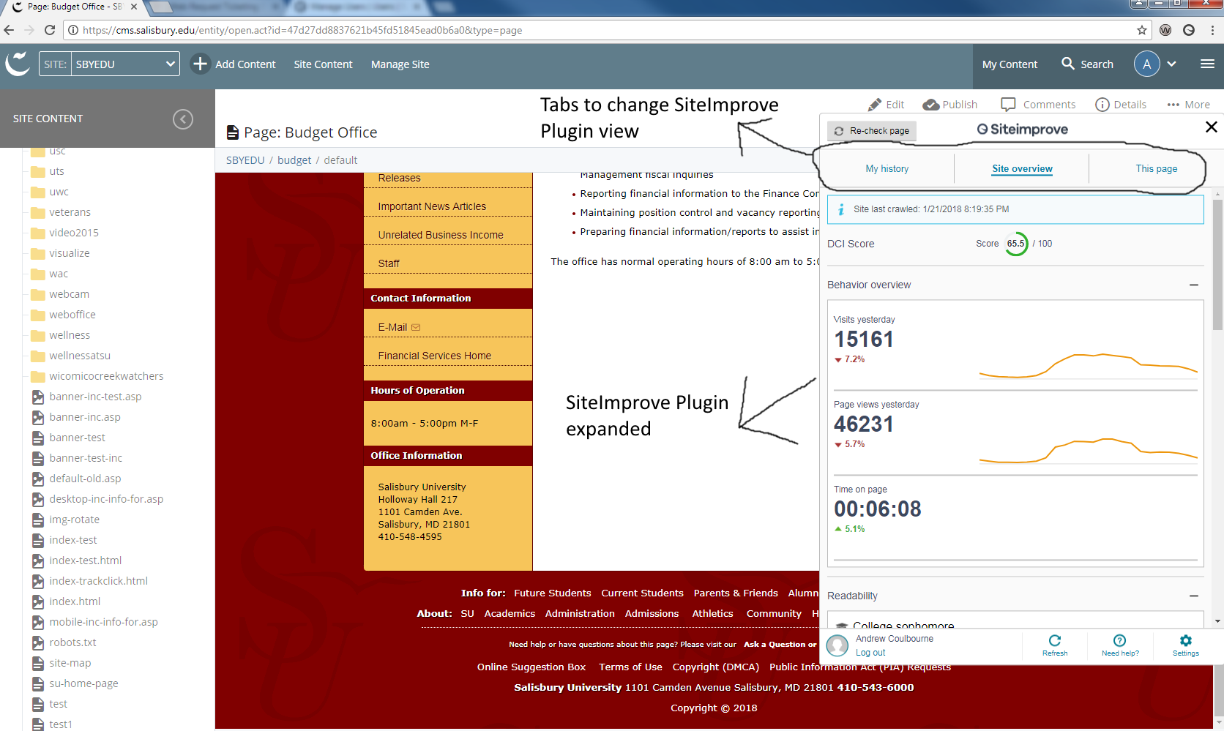

- How you can use the Information in each view
  - The “My history” tab is straight forward in that is presents you with pages that you have viewed while using the SiteImprove plugin. It also list the number of ADA issues found on each of your recently visited pages. This tab provides an easy way to ensure all pages worked on recently are compliant before finishing your CMS session. Below is an enlarged image of the “My history” tab.
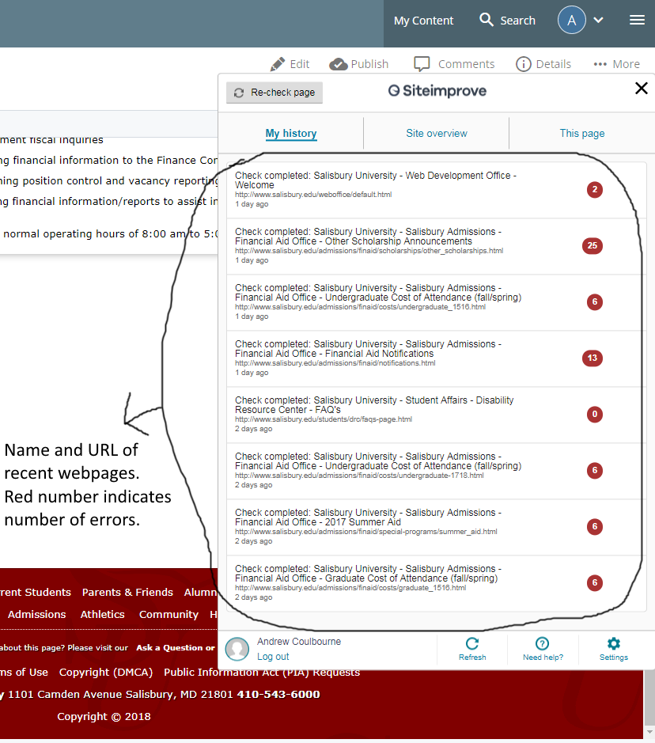
  - The “Site Overview” tab provides accessibility and analytic data for the entire Salisbury domain. By itself this tab won’t provide much information that our typical CMS user will find useful. However combining the information in the “Site Overview” view with Analytic and ADA compliant information found on the “This Page” tab (covered in the next step) allows a user to see how their page compares to the SU average for pages which helps users make content decisions.
    - The first piece of information you will see on the “Site Overview” tab is the DCI Score for our entire website http://www.salisbury.edu/. This score is a combination of how accessible (ADA complaint), searchable (how easily search engines find our pages), and Quality (is information up to date/useful) of our website. Your pages should have a DCI score higher then Salisbury’s Average if not contact the web office as ask how we can help.
    - While this tab contains other information as well most will not be useful to the typical CMS user. The behavior overview section provides an overview of “Visits this month” to our website and “Page views this month” to our website. While CMS users might find this interesting. This information is for our entire site and hard to leverage for individual department sites. Below in an image showing an enlarged view of the “Site Overview”
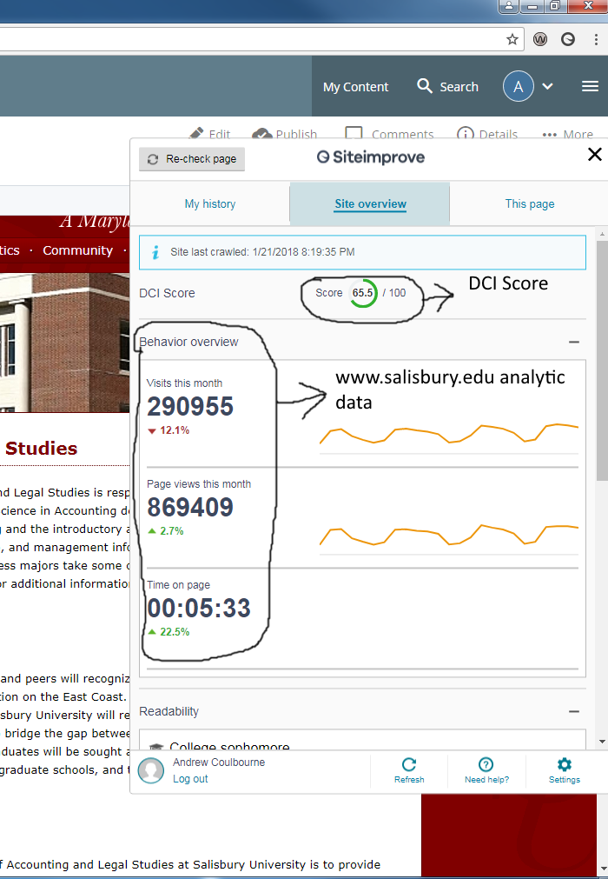

  - The “This page” tab will be the most useful and most used tab by our CMS users. This tab provides analytic and ADA compliant information for any individual page in the CMS. You must be viewing the page you want information on in the CMS in order to make use of this tab.
    - Just like the “Site Overview” tab the “This page” tab has a DCI score located at the very top. This DCI score is for the page you are viewing if this DCI score is lower than the one on the “Site Overview” tab there is mostly likely something that can be done to improve the usefulness of this page to a user.
    - Also inside of the “This page” tab is a section that list any issues that exist on this page. These errors consist of ADA compliance issues. Search ability issues and broken links and misspellings. All of which effect a pages DCI score. The most important issues to fix are the ADA complaint issues which are label either “A errors”, “AA errors” or “AAA errors”. Single A errors are the most egregious errors with triple A errors being smaller issues. Clicking on any of the boxes listing errors will open a SiteImprove page checker in your browser detailing the issues on the page. While we don’t expect CMS users to fix the majority of issues on a page themselves this provides a way to alert the web office about these issues and allow us to fix them.
    - The “This page” tab has two sections one called “Page Content Issues” which was detailed in the above steps. The other section is “Page Analytics”. This provides Analytic information for this individual page. Below are enlarged images of both sections highlighting areas of interest.
