**TOPIC:** PeopleSoft Custom Bolt-on Adjunct Contract Renewal – Signing Order & Instructions

____________________________________________________

Adjunct Contract Renewal Signing Order & Instructions



A Custom Bolt-on PeopleSoft Application

**TOPIC:** PeopleSoft Custom Bolt-on Adjunct Contract Renewal – Signing Order & Instructions

____________________________________________________

Once the Adjunct Contract Renewal Submitter has completed their part of the process, the contract will flow through the DocuSign process. The steps are as follows:

Step 1: ***DocuSign*** email is received by the Chair for review and Pre-Approval

Step 2: ***DocuSign*** email is received by the Faculty member for signing

Step 3: ***DocuSign*** email is received by the Chair for signing

Step 4: ***DocuSign*** email is received by the Dean for signing

Step 5: ***DocuSign*** email is received by HR for processing

Step 6: HR processes and ***ALL*** are copied via email on the final signed contract

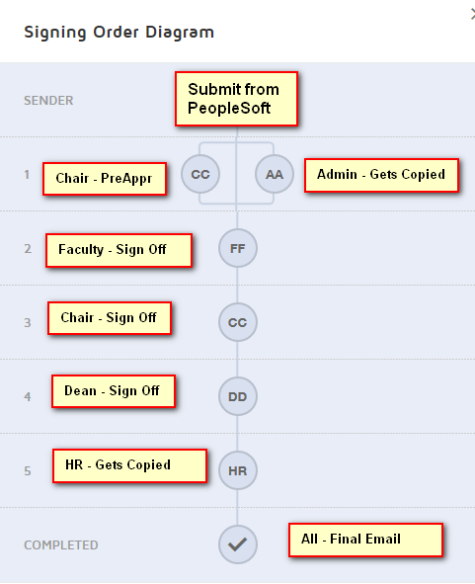

***For instructions on how to complete a ***DocuSign*** signature please see the link below.

<https://support.docusign.com/en/videos/New-Signing-Experience>